
King Abdulaziz University

Faculty of Computing & Info Tech.
Computer Science Department
Mid Exam (12-4-1445 / 15-10-2024)

Course: CPCS351 (Software Engineering-I)
Term: Fall (2024), Time: 80 Minutes

Student ID: ------------------------------------------Section: ---------------------------------------
Student Name: -----------------------------------------------------------------------------------------

Mark with a check sign in front of your instructor name
- Dr. Wajdi Aljedaibi
- Dr. Abdulaziz Attaallah

Max. Points | Points Obtained
100
Max. Marks | Marks Obtained
20

PART I : Multiple Choice Questions
Answer the following questions by circling only one correct answer.
(Total 36 pts and 2 pts for each question)
- To ensure high-quality software, how should software engineering practices be applied?  A. Only in the early stages of development  B. Throughout the entire software development life cycle  C. Primarily during testing and debugging  D. Flexibly based on project size and complexity | CLO 1,2
- After the requirements analysis phase, which activity is generally undertaken later in the software development life cycle?  A. Establishing the project timeline  B. Creating design documents  C. Conducting usability testing  D. Gathering feedback from users | CLO 1,4
- In object-oriented programming, how are real-world concepts modeled?  Options:  A. As functions and procedures  B. As data structures and algorithms  C. As classes and objects  D. As actors | CLO 1,9
- What is the main objective of implementing quality assurance practices in a software development project?  A. To ensure the software is user-friendly  B. To identify and resolve defects prior to release  C. To track project progress and timelines  D. To collect requirements from stakeholders | CLO 1,2,4
- Which of the following techniques is most effective for understanding user requirements in software development?  - User interviews  - Source code analysis  - Performance testing  - System integration | CLO 3,5,6
- In UML, what relationship represents a "part-of" association between classes?  Options:  A. Aggregation  B. Generalization  C. Dependency  D. Association | CLO 9
- What is the primary purpose of a use case diagram?  A. To model the internal structure of a software system  B. To visualize the interactions between objects  C. To describe the general functionality and behavior of a system  D. To document the detailed design of classes and methods | CLO 9
- What are functional requirements primarily concerned with?  A. The specific features and capabilities of the software  B. The performance, usability, and reliability of the software  C. The user interface design and layout  D. The development methodology and tools used | CLO 5
- The ………. quality of software is determined by the ………. quality.  - analysis, coding  - product, development  - testing, system  - process, maintenance | CLO 2,4
- What is the most noted feature of the Waterfall model?  - Simultaneous phase execution  - Continuous integration  - Sequential phase progression  - Incremental delivery | CLO 7
PART II : Short Answers
(Total 16 pts)
- What is a fundamental characteristic of the Spiral model in software development?  It emphasizes iterative development and risk management. | CLO 7  2pts
- What type of relationship indicates inheritance when analyzing entities?  "is a" | CLO 9  1pts
- In a short statement, describe the relationship between class A and class B when A contains B.  B is part of A. | CLO 9  2pts
- What are the essential elements commonly found in an effective software analysis document?  Requirements from the domain. | CLO 4,5  2pts
- During which phase of the software development life cycle are the specific needs and constraints of users and stakeholders comprehensively analyzed and documented?  Analysis phase. | CLO 1,3,4  2pts
- Describe why non-functional requirements are important?  Non-functional requirements are important because they define the quality attributes of a system, such as performance, usability, reliability, and security. These requirements help ensure that the software meets user expectations and operates efficiently under various conditions. They also guide design decisions and impact overall system architecture, ultimately contributing to user satisfaction and the system's success in real-world applications. | CLO 4,6  4pts
- What do we call an entity in an application that possesses an "independent existence" instead of being classified as an attribute?  Class. | CLO 1,3  1pts
- What technique can be employed to collect feedback and insights from stakeholders about a system?  Administering a survey to stakeholders. | CLO 7  2pts

PART II : Requirement Identification
(Total pts 20 and 2.5 pts for each answer)
Identify the functional (F) and non-functional (NF) requirements from the given list of requirements for EventConnect is a platform that brings together event organizers and entertainment seekers, allowing users to find, book, and get notifications for concerts, shows, and festivals based on their location, interests, and availability.

# | Requirements | Functional (F) / Non-Functional (NF)
1 | The system should implement high-level security measures for safe online payments and data protection. | NF
2 | Users should be able to search for events based on location, date, genre, and ticket availability. | F
3 | The platform should be able to handle a large number of concurrent users during high-demand periods (e.g., popular concert ticket releases). | NF
4 | Event organizers should be able to create event listings, including details like date, location, pricing, and availability. | F
5 | The application should be optimized for use on both mobile and web platforms to ensure accessibility. | NF
6 | The platform should allow users to book tickets and receive electronic tickets through email or the app. | F
7 | The user interface should be visually appealing and easy to navigate to enhance user experience. | NF
8 | Users should be able to follow their favorite artists or venues and receive notifications about upcoming events. | F

Part III: Problem-Solving and Diagramming
(44 total pts)
Based on the following problem description of a movie rental system, show:
- Use Case Diagram [19 pts] CLO 5,6,7,9
- List of all candidate classes [6 pts] CLO 5,6,9
(identifying potential classes that represent entities, concepts, or components within the problem domain, which could be part of the system's design.)
- UML Class Diagram [19 pts] CLO 5,6,9

MovieHub is an online platform for renting movies and TV series, offering a large catalog of genres and titles for users to rent or purchase for streaming. The system allows different types of users, such as Admin, Customer, and Content Provider to interact with the platform. The Admin manages the content, updates the catalog, monitors user activities, and handles user accounts, while the Customer can create an account, search for movies, view trailers, add movies to their rental cart, and make payments. The Content Provider is responsible for uploading movies and ensuring proper digital rights management.
MovieHub supports various payment methods, including Credit/Debit Cards, PayPal, and Gift Cards. Upon renting a movie, the Customer can stream it for a limited period (e.g., 48 hours). When a Customer purchases a movie, they gain permanent access to stream it anytime. To ensure a smooth user experience, the platform uses adaptive streaming technology that automatically adjusts video quality based on the user's internet speed.
The platform provides the following services:
- A Search Engine to find movies based on title, genre, year, and ratings.
- Customer Profile Management: Users can update their profile information, manage their rented or purchased content, and check transaction history.
- Wishlist: Customers can add movies to a wishlist for future renting or purchasing.
- Ratings and Reviews: After streaming a movie, customers can leave ratings and written reviews to share their viewing experience.
- Promotions & Discounts: The Admin can create and manage promotional offers, such as discounts on rentals or bundled packages.
The Admin also has access to a Content Analytics Dashboard to view stats like rental frequency and purchase trends, while Content Providers can track the performance of their uploaded content. For user security and easy access, MovieHub includes a User Authentication System that supports secure logins, including options for social media login through platforms like Google and Facebook.
With an intuitive user interface and secure payment gateway, MovieHub ensures a seamless entertainment experience for users and comprehensive content control for administrators.
Use Case Diagram

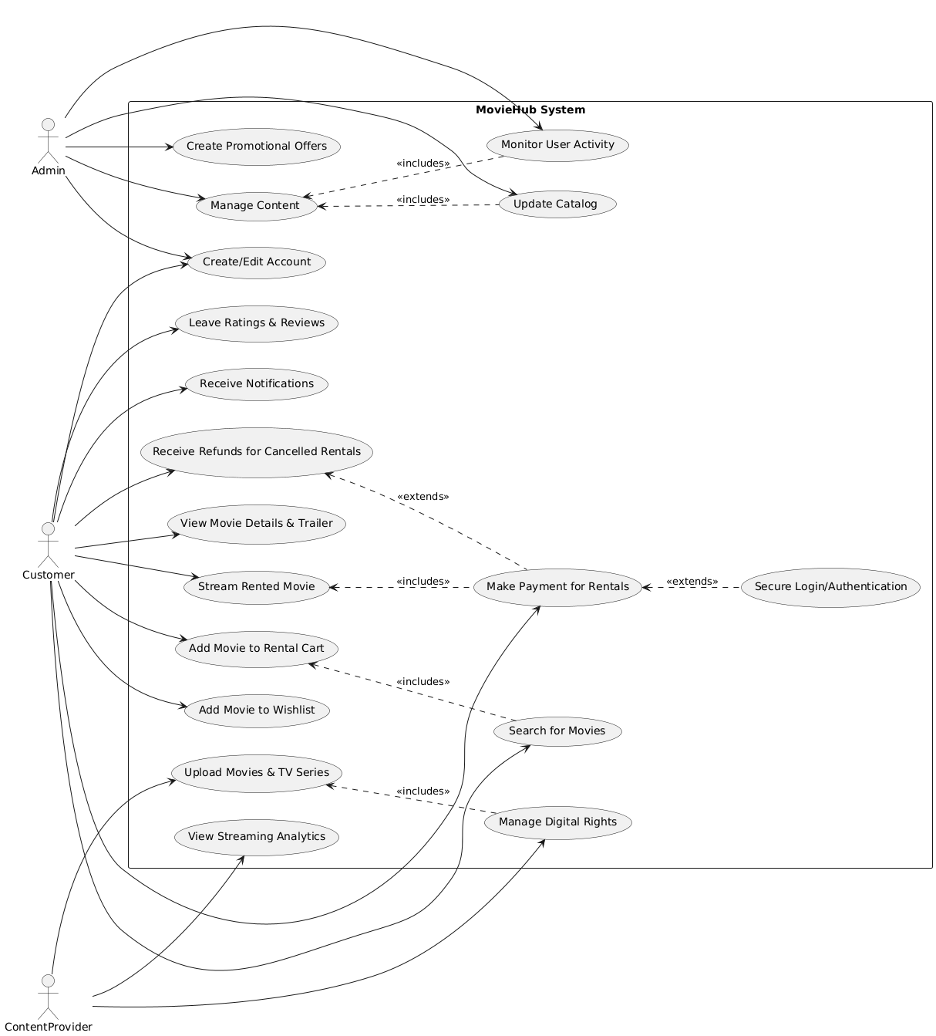

List of all candidate classes
- User: General class representing all types of users (Customer, Admin, Content Provider).
- Customer: A user who rents or purchases movies and can leave reviews.
- Admin: A user with permissions to manage content, user activities, and promotions.
- ContentProvider: A user responsible for uploading movies and managing their content.
- Movie: Represents a movie or TV series available on the platform.
- Transaction: Captures the details of rental or purchase payments.
- Payment: Handles payment information and processing methods.
- Review: Represents customer ratings and comments on movies.
- Promotion: Represents discounts or special offers for movies.
- StreamingSession: Tracks the streaming activity of movies by users.
- Wishlist: A collection of movies that a customer wants to rent or purchase.
- Catalog: Represents the entire collection of movies and TV series available.
- Notification: Manages alerts and notifications for users about new content or promotions.
- SearchEngine: Facilitates searching for movies by title, genre, and other filters.
- Profile: Represents user profile details and settings.
- AnalyticsDashboard: Provides statistics on user activity and content performance.
- DigitalRights: Manages digital rights and protections for uploaded content.
- Discount: Specific details of the discount applied to a movie or bundle.

UML Class Diagram

